# CHAPTER 1 | INTRODUCTION

## **Overview**

The job seeker searches the jobs for apply and the company want an efficient Job seeker with specific certificated from job seeker and skills the online Job portal objectives fill gap between search in traditions ways be Introduce more efficient ways the company post the jobs in website determined all requirements for job seeker desirable with skills for apply this gives easy life and more efficient way.

## **Background and Motivation**.

The Job search is one of the most important processes that all graduates in all disciplines provide a site that facilitates job searches in various fields and disciplines and facilitates the companies to find an employee to be feasible

without the lowest effortMaintain Job Seeker and Employer recordsMaintain uploaded Resumes Provide Customized Job PostingsMaintain Job Posting details and generate various reports



## **Statement Problem**

The current system requires applicants to search through print and visual media for employment opportunities. Applicants must apply for jobs using traditional methods and appear for an interview on a specified date at a specified location. Employers need to advertise job vacancies, sort all applicant details, make selection procedures and complete procedures. This approach is tedious and requires a lot of effort and resources. An online job portal is needed where applicants find jobs easily and employers can find suitable candidates for the job.



## **Solution**

The online job portal is solution for problem with jobs announcementsand system requires to search

Jobs with add jobs and cv applicants with strategiessolutionfor three modules:

**Job seekers**

Can enter cv and details for the personal information, certificate and related jobs he to introduce in the company add files to websites

**Employer**

He is adding jobs to the websites and flow company for jobs seeker and determines what specific skills for

jobs seeker to introduce jobs post

**Admin**

Can management the online websites add, update and delete the user, company or employee Authentication the system with password and user for admin with special role for management



## **Project Goals**

The main objective of the online job portal project is to manage job details, CV and job seeker. Manages all job-related information. The purpose of the project is to build an application to reduce the manual work of managing job vacancies.

## **6 Project Objectives**

Store data records of the applicant's work and employer

Maintaining submitted CVsProviding customized job vacancies

Maintain job posting details and generate various reports

Support notification and message

Display data for related search words

Category jobs and company and job seeker



## **Project Scope**

The Scope for the system can be as follows: - Maintain Job Seeker and Employer Records Maintain Uploaded Resumes Provide Customized Job Postings Maintain Job Posting details and generate various reports The system after a careful analysis has been identified to be presented with the following **Modules**:AdminJob SeekerEmployer



## **Hardware and Software Tools**

|  |  |
| --- | --- |
| ITEM | SPECIFICATION |
| RAM | 40 GB to 16gig |
| Hard Disk | 80 GB |
| Display | 1024 * 768, True Type Color-32 Bit |
| Processor | Intel I3 and above |
| Modem | Modem to connect internet |

Table **1**Hardware Requirments

|  |  |
| --- | --- |
| **software** | **Uses** |
| Visual Studio Code  Android Studio  Visual Studio 2019 | For development website |
| Xampp | Create a local website for programming on two computers |
| HTML | Create and design pages and websites |
| Css | Used and design sites |
| Bootstrap | Uses and design sites help to design and apply websites |
| Windows 10 version 2021 or higher  Or windows 11 | For environments’ |
| Git | For control version of the system |
| JS | Uses mainly in web browsers to create more interactive pages |
| PHP | Used for development and programming web applications |
| MYSQL | System database (Back-end) |

Table **2** Software requirements

## **Work Breakdown Structure and Gantt chart**

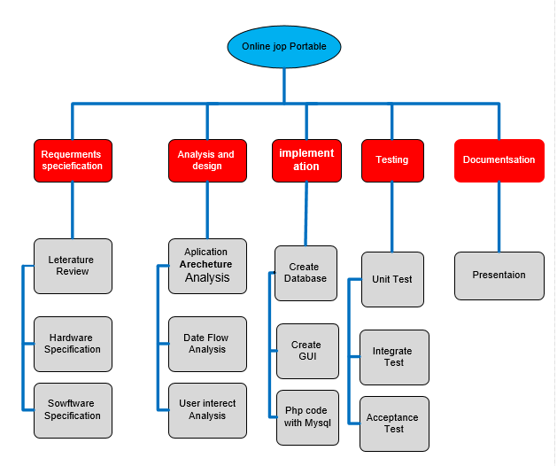A work breakdown structure, or WBS, is a project management tool that takes a step-by-step approach to complete large projects with several moving pieces. By breaking down the project into smaller components, a WBS can integrate scope, cost and deliverables into a single tool. While most WBSes are deliverable-based.

### **Work Breakdown**

Figure 1: Work Breakdown Structure

### **Gantt chart**

A Gantt chart is a project management tool assisting in the planning and scheduling of projects of all sizes, although they are particularly useful for simplifying complex projects. Project management timelines and tasks are converted into a horizontal bar chart, showing start and end dates, as well as dependencies, scheduling and deadlines, including how much of the task is completed per stage and who is the task owner. This is useful to keep tasks on track when there is a large team and multiple stakeholders

when the scope changes a visual display of the whole project, timelines and deadlines of all tasks,

relationships and dependencies between the various activities, project phases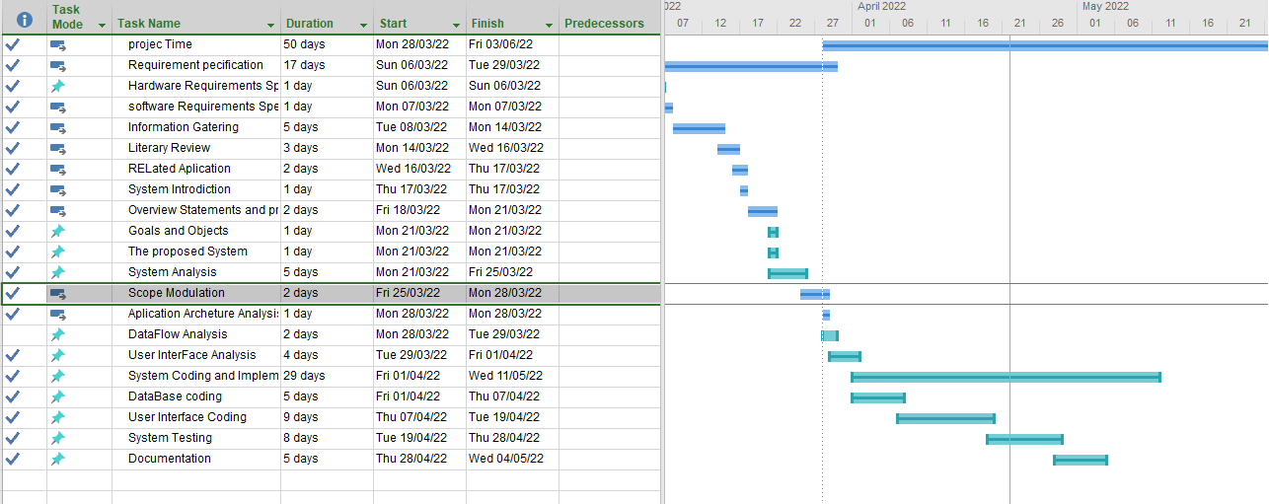

Figure 2 : Gantt chart